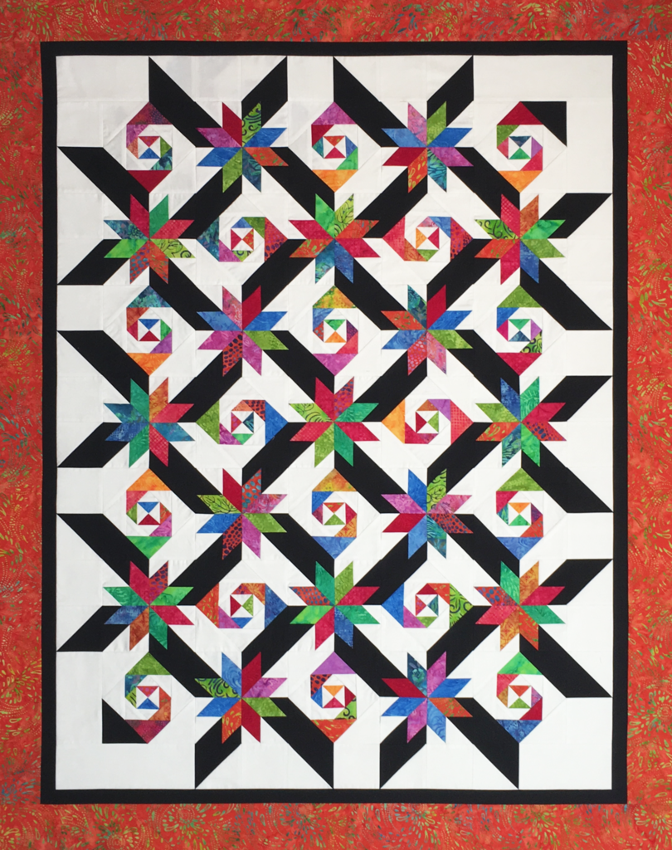
Lemoyne Trails
Project Size: 45” x 57 “

Lemoyne Trails uses the combination of Lemoyne Stars and Snails Trails blocks with special color placement to achieve this stunning look. This pattern incorporates the new Stacked Squares Technique Sheet by Deb Tucker in making the Snails Trail blocks. Lemoyne Trails is a fat quarter friendly pattern, calling for at least 6 different assorted fabrics. If you want no repeats in the star points, choose at least 8 assorted colors.

Fabric Requirements: (Colors refer to pictured quilt)
- Background (white) - 1 ¾ yards
- Accent (black) –1 1/8 yards
- Star Points (assorted colors) - 8-12 fat quarters or scraps to equal around 2 yards.
- Inner Border (black) - ¼ yd.
- Outer Border and binding (focus) - 1 ¼ yd.
- Backing Fabric – 3 yards

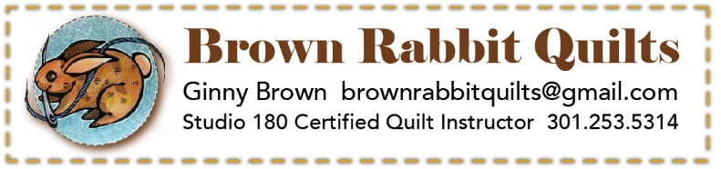
Pre-Class Cutting Instructions (WOF = width of fabric, approx. 40”)

Pre-cutting must be done prior to class to ensure
maximum instructional and sewing time. There are
Class Supplies

- Studio 180 Design Lemoyne Trails Pattern
- Studio 180 Design Rapid Fire Lemoyne Star Tool
- Studio 180 Design Square Squared tool
- Studio 180 Tucker Trimmer 1
- Quilters Magic Wand (recommended)
- Invisigrip recommended for back of tools
- 6” x 12” and/or 6” x 24” Ruler
- Cutting Mat & Rotary Cutter (with new blade)
- Fabric pre-cut for class – see cutting instructions
- Sewing machine in good working order
- Thread & bobbins
- General sewing kit – scissors, pins, seam ripper, machine needles, etc.

many similar size pieces, so please keep them separate in labeled zip top bags or paper plates.

Background Fabric - Cut the following:
(9) 3" squares
(10) 4" squares
(18) 2 ½" squares cut in half on the diagonal
(18) 2 ¾ " squares cut in half on the diagonal
(18) 3 ½ " squares cut in half on the diagonal
(18) 4 ¼ " squares cut in half on the diagonal
(7) 3 ¼" WOF strips cut into 14 half strips

Fat Quarter Assorted Colors - Cut the following:
(18) 2 ½" squares cut in half on the diagonal
(18) 2 ¾ " squares cut in half on the diagonal
(18) 3 ¼ " squares cut in half on the diagonal
(9) 3" squares of different colors
(28) 2" Half WOF strips for star points (if using Fat
Quarters, cut strips on long side)
More cutting will be required for finishing. The cutting listed will be sufficient for class.
Dark Accent - Cut the following:
(18) 4 ½" squares cut in half on the diagonal
(7) 3 ¼" WOF strips cut into 14 half strips
(10) 4" squares

